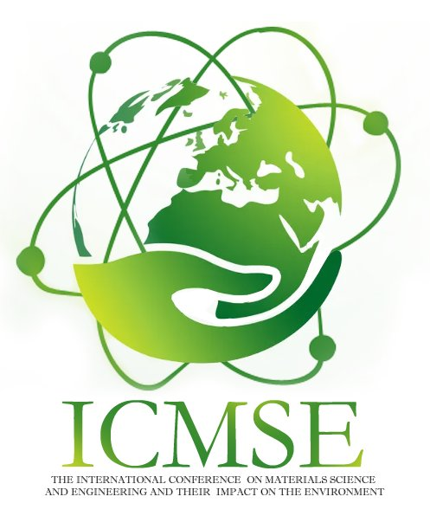

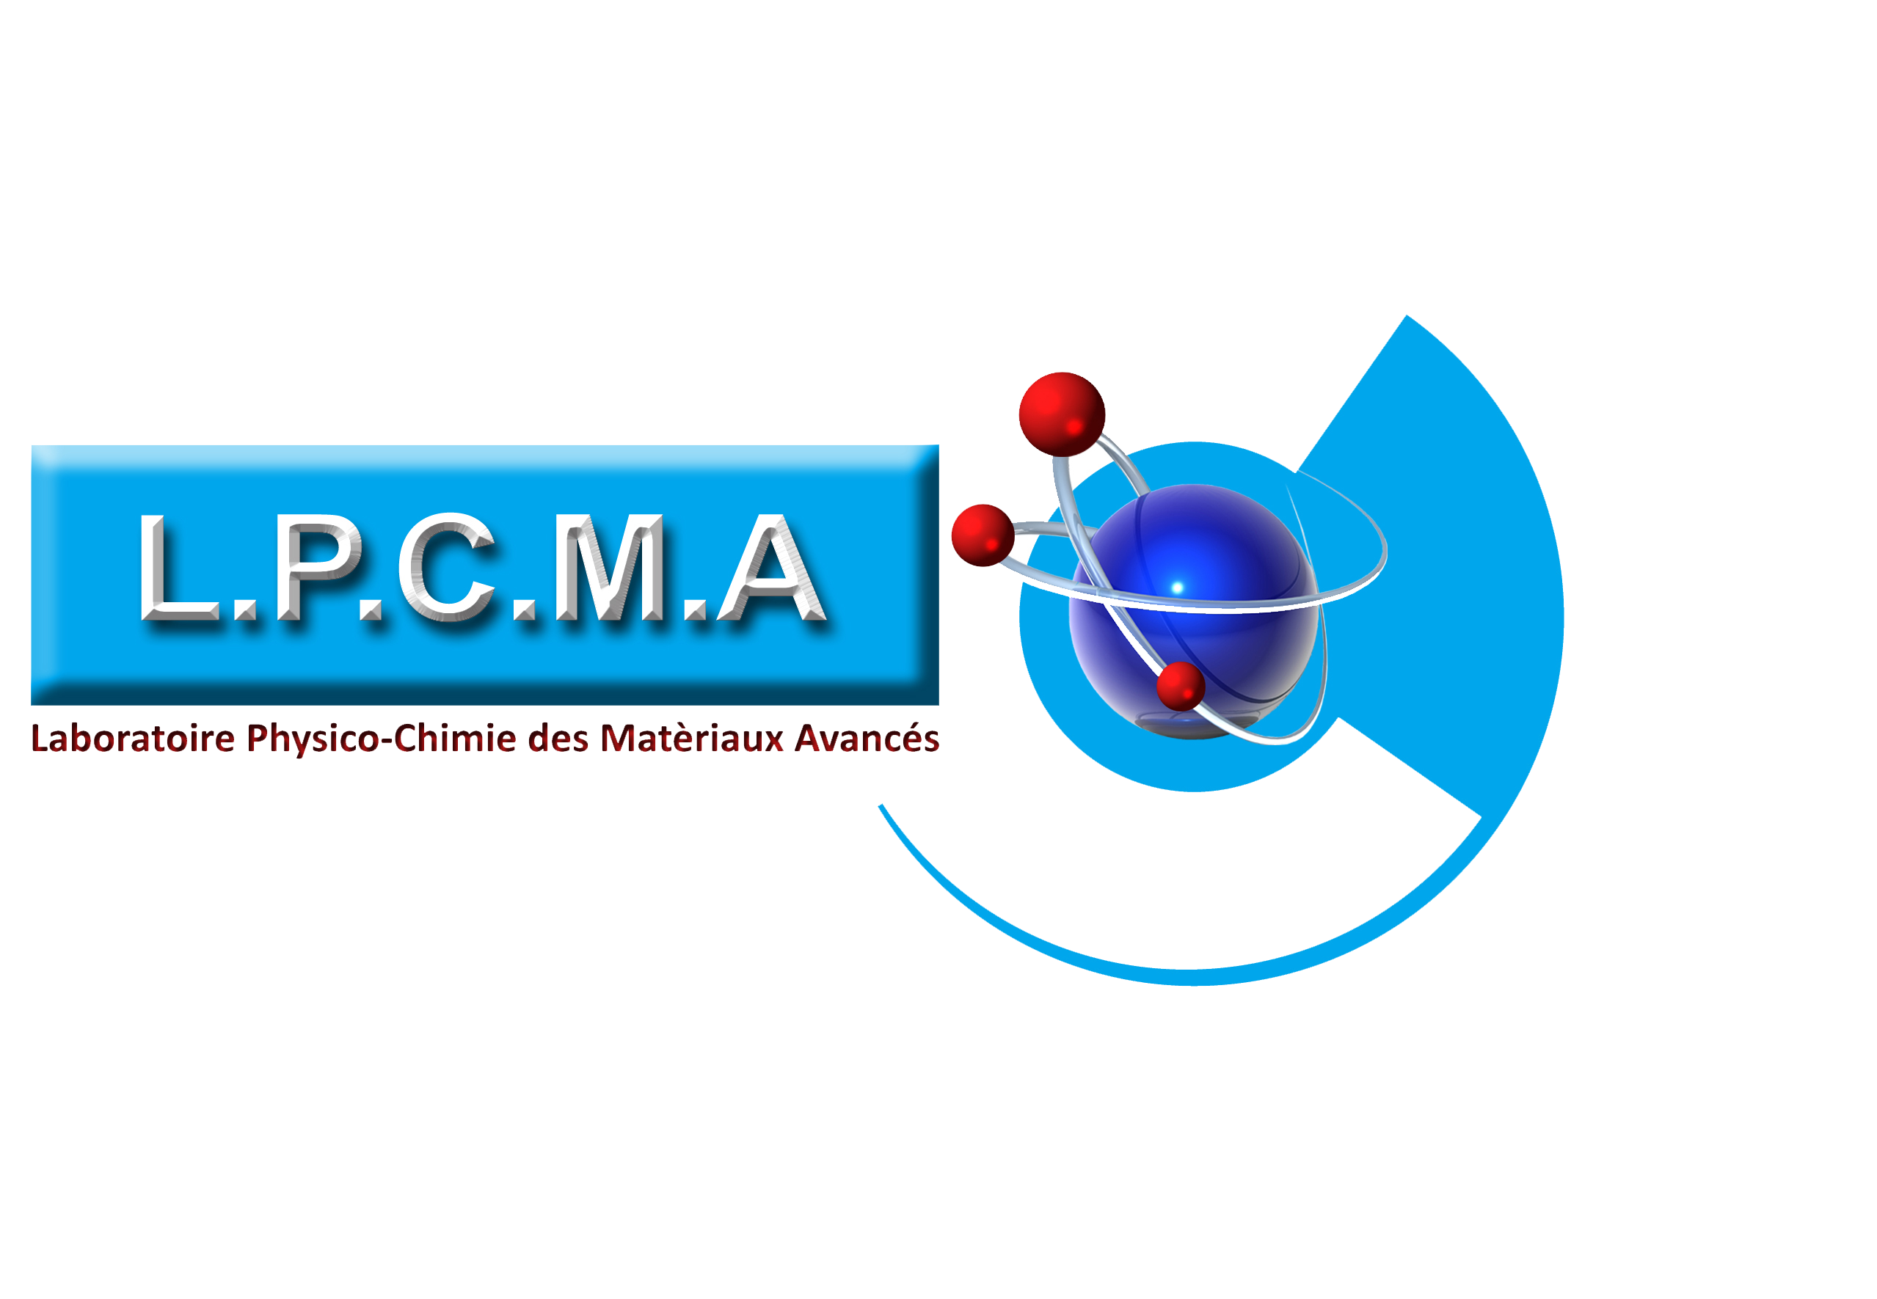

ICMSE’2025

The fourth edition of the international conference on materials science and engineering and their impact on the environment

Title: Template and Instructions for Abstracts (14 Times New Roman/ Blod)

Presenting author’s nameª, Co-author^{b}, Co-author^{c}, …

ªAuthors’ Department, Institute, Organisation, Country
^{b} Authors’ Department, Institute, Organisation, Country
^{c}Author’s Department, Institute, Organisation, Country

Corresponding Email:
Abstract:
Text of the abstract........................................................................................................................
.......................................................................................................................................................
.......................................................................................................................................................

Key words: ..................., ...................., ................................., .................................

